Sprint Report  
Sprint 6 Submission

Submission Date: 15 March 2021

Team A

Gregorson Mahon T00057640

Taylor Peck T00483746

Nicholas Piluso T00586492

Contents

List of tasks for the previous week 3

List of tasks for the coming week 4

Application Server Backlog: 4

Web Site Backlog: 5

Project Management Tool Screenshot 6

Updated Mock-ups or Other Relevant Documents 7

# List of tasks for the previous week

|  |  |
| --- | --- |
| Task Name | Responsible Team Member |
| **Team Meeting for …**   * Team updates & discussion on what needs to happen next | All Team Members |
| **Continue development on web site:** | Taylor |
| **Continue development on web site:** | Gregorson |
| **Continue development of the Application Server:**   * Calculate which properties are inside which new outages and add a PropertyOutage record to the DB * Retrieve user contact settings & property info from DB for updated/new outages so that informative messages can be created and sent to these users (add DB functionality to AppModelDB.py) * Rename AppModelRetrieveJSON.py to AppController.py and move non-controller functions (json functions, etc) to their own Model files. * Deactivate PropertyOutage records in the DB where power has been restored to a property * Send outage messages in the list ‘*ListOfOutageMessages*’ to the users | Nick |

# List of tasks for the coming week

|  |  |
| --- | --- |
| Task Name | Responsible Team Member |
| **Team Meeting for:**   * Team updates & discussion on what needs to happen next | All Team Members |
| **Continue development on web site:**   * Complete login & user verification work (resolve bugs, etc.) * Begin work on main page components | Taylor |
| **Continue development on web site:**   * Create and implement a universal CSS theme for the pages. * Update database to store property longitude & latitude information | Gregorson |
| **Continue development of the Application Server:**   * Perform some much-needed unit, component and release testing for App Server. | Nick |

# Application Server Backlog:

1. Perform unit, component and release testing for App Server. ***(Assigned to Nick March 15th 2021)***
2. Reactivate a PropertyOutage in the DB where power has been lost again - if it was previously restored (use UpdatePropertyOutages in AppModelDB.py) (This is a low-priority item)

# Web Site Backlog:

* controller: cases for posted commands SignOut, NewProperty, EditProperty, NewRecipient, EditRecipient, Notifications (get updated information from database via model methods, build and return HTML or return as JSON where ideal i.e. tables). ***(Assigned to Gregorson March 8th 2021***)
* mainpage HTML and CSS (mostly will probably be handled by means of the controller a la the single page application method), JavaScript methods for parsing JSON.
* startpage: Get user existence validation working, and possibly in real-time.
* Create and implement a universal CSS theme for the pages. (***Assigned to Gregorson March 2nd 2021***)
* Functionality to enable users to create an account/sign in (methods in model.php to check if user’s information entered is valid, to add a new user, check if their account is locked). (***Assigned to Taylor March 2nd 2021***)
* Functionality to add and edit a property (methods to add a property into the database and update the database listing).
* Functionality to add and edit a recipient (methods to add a recipient to the database, update their information).
* Password reset functionality.
* Reconfigure UI of pages to improve UX (long term goal, somewhat dependent on what we learn in this course).

# Project Management Tool Screenshot

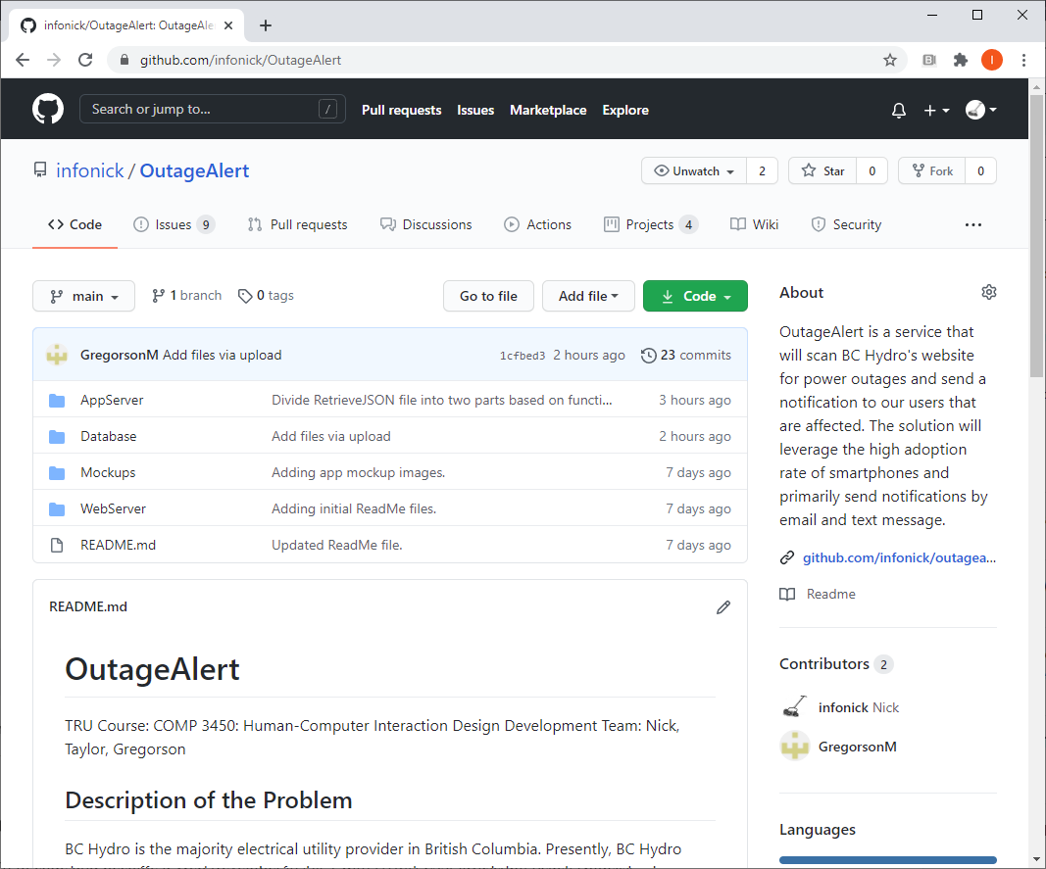

Interested readers may review the GitHub: <https://github.com/infonick/OutageAlert/>

# Updated Mock-ups or Other Relevant Documents

“You can include any other information such as screenshots of your app in progress or mock-ups showing what you plan to do in the coming week.”

N/A for this sprint